FOR SALE
1990 40’ J BOATS / J-40

Wonderful Cruiser/Racer with shoal draft wing keel and excellent sail inventory. Repowered in 2003 with 40 hp Yanmar diesel engine. Beautiful teak interior with teak & holly sole throughout.
**NEW GARMIN 8610 CHARTPLOTTER AND RADAR INSTALLED JULY 2019**
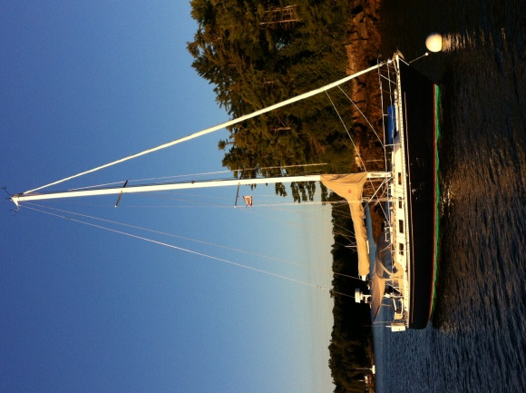
LOA: 40’ LWL: 34’ Beam: 12’ Draft: 5’
Displacement : 18000 lbs +/- Engine: 3JH3E, <1000 hrs
Fuel: 35 gal Water: 120 Holding tanks: 2

- 110 V Shore Power
- 110 V Battery Charger
- Espar Cabin Heater
- SeaFrost Refrigeration with both AC &
Engine cooling
- Force 10 propane 3-burner gas stove
- Lofrans Anchor Windlass w/ salt water washdown
- Below decks Autopilot
- Folding three-blade prop with spur line cutters

For Pete’s Sake
Accommodations
Sleeps 7 with V berth forward, expandable cushions in main salon with fold down bulkhead table, and private aft cabin.
Large U-shaped Galley to port, two heads with showers,”Y” Valves & macerator pump forward. Abundant hanging lockers and bookshelves. Aft facing nav station to starboard. Fitted Sheets for V berth and Aft Cabins included.

Sails & Rigging
*Hallett Sails
- 2017 Tri-radial 100% blade Jib*
- 2014 Tri-radial Dacron Main*
- 2013 Modified 135% Kevlar Jib*
- 1990 Dacron 135% Dacron Jib
- 1990 storm Trysail & storm Jib
- Harken Roller Furling headsail unit
- 2 Lewmar #54 self-tailing primaries
- 4 Barient self-tailing Main & Halyard winches
- Forespar Carbon Fiber Whisker pole
- Assymetrical w/ Stowsock & symmetrical spinnakers

L
Electronics, Hull & Deck
- Leather-wrapped wheel
- Cockpit Dodger & Awning
- 35 lb. CQR Anchor, Chain & Rode
- Swim Ladder & Cockpit Shower
- Outboard Motor Davit

- NEW Garmin GPSMAP 8610 Chartplotter & GMR 18XHD Radar
- B&G Hydra Autopilot & Speed/Depth instruments
- Horizon GX1500 VHF w/ remote access Mic. MMSI enabled
- Sony Stereo/CD player
- 3-blade folding prop w/ line cutting spurs

Asking Price: $89,500. By owner Peter Curtis 207-415-6973 (pfcurtis@aol.com)

