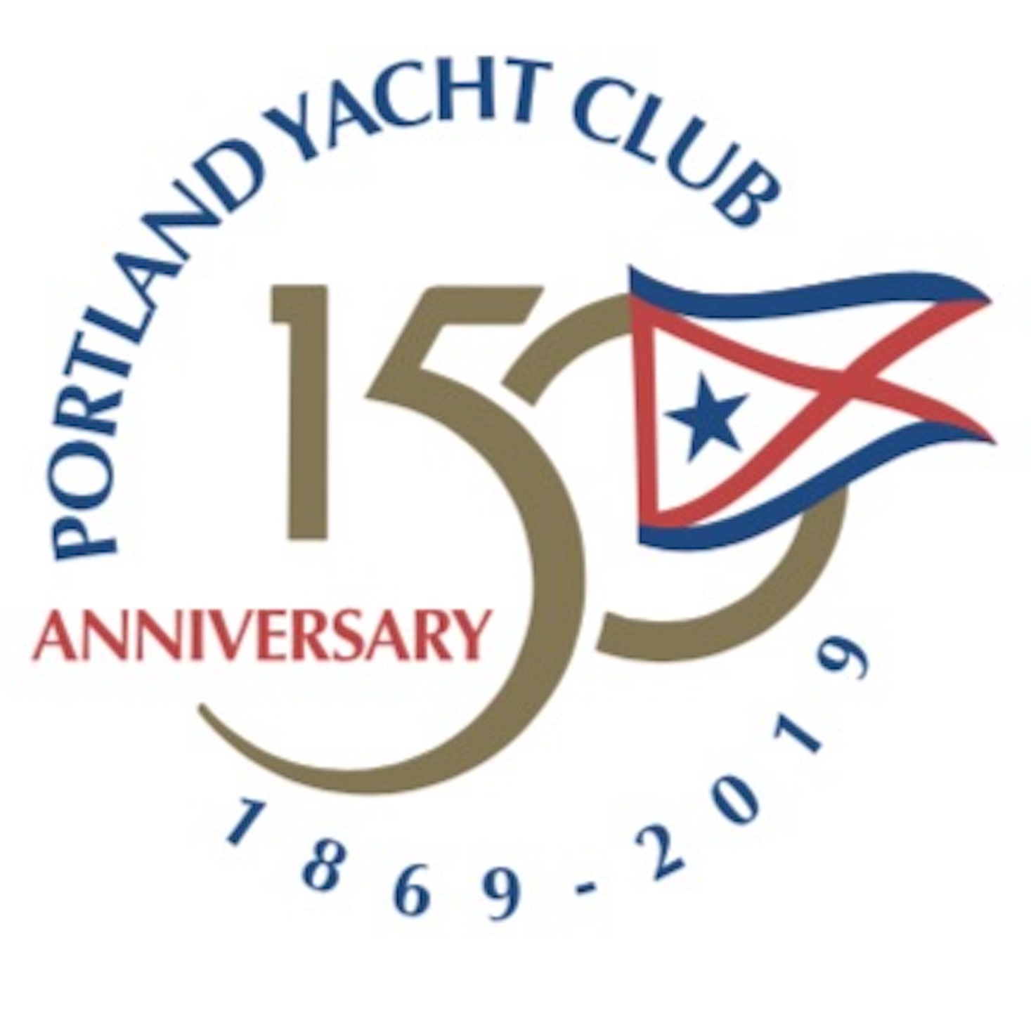

Clubhouse Location Dates

1873 A Clubroom was rented on Custom House Wharf with a balcony overlooking the anchorage.

1884 A new Clubhouse was built on Merchant’s Wharf for $2,500 (around this time land was purchased in South Portland)

August 10, 1926 A fire, which started on Brown’s Wharf, destroyed the Clubhouse on Merchant Wharf and all items were lost.

1926 A new Clubhouse was built on Merchant’s Wharf to replace the one destroyed.

Around 1942 With the outbreak of WWII, the US Coast Guard took over PYC’s Merchant’s Wharf Clubhouse

1947 The Club moved to a cottage it purchased on the Falmouth Foreside.

